aem project 4512

An "ultra-graphics" adaptor for the VZ200/300 computers
Matthew Sorell

Are you sick of the graphics and text restrictions on your VZ200/300? Then this project is for you. Offering 256 new characters, including upper and lower case, Greek, DATA70, mathematical and other symbols, as well as graphics up to six times the normal resolution, the Ultra-Graphics extension board is a must for the serious VZ200/300 owner.

INSIDE THE VZ computer lies a very versatile video IC. Unfortunately, the designers were working an a low budget machine and so the graphics capabilities are quite limited. However, by extending the amount of video RAM used, adding a character generator EPROM and a few other ICs, the graphics capabilities of both the VZ200 and VZ300 can be fully realised.
The first problem, then, is to fit 6K of RAM into a 2K memory position. To do this, a latch was used to provide an extra two address bits to bank switch an 6K RAM into the normal 2K of video RAM space, in position 7000-77FFH (28672-30719). As an 8K RAM is used, but the highest resolution available only uses 6K, an extra 2K of general data storage RAM is available. This can be used, for example, to store character definitions for use in high resolution graphics.
The latch used was installed into I/O address 20-2FH (32-47), which is the same position as the joystick controller. However, as the joystick is a Read-Only device, a Write-Only Latch will not interfere with it. The latch also controls the new graphics and text modes.
A word of warning: This project is an extensive internal modification to the VZ200 or VZ300 computers. If you are not

CHART 1. The new character set. Note the addition of special symbols, Greek and maths symbols and Data 70 characters.
confident about modifying the computer, then i recommend you do NOT attempt this project without experienced help. I also strongly recommend you obtain a copy of the "VZ300 Technical Manual", which will assist you if problems arise. Building this project also voids the manufacturers warranty, so it's best tackled after your machine's warranty has expired.

New characters, extended graphics
The new character set is shown in Chart I here. It was originally designed to be compatible with the VZ word processor (tape version). Thus there is the 96 standard ASCII characters, which are slightly out of order to be more compatible with the standard VZ text. There is also a DATA70 ("computer" type) character set, a Greek character set, some international characters, and mathematical symbols which can be accessed by poking their code into video memory, or printing the correct semigraphics character in the right colour. A dedicated screen controller routine could also be used.
The new graphics modes serve many useful purposes. The highest resolution graphics mode (256 x 192 pixels), is equivalent to the resolution in text mode, and so can be used either for text, using a suitable driver routine, or for graphics,

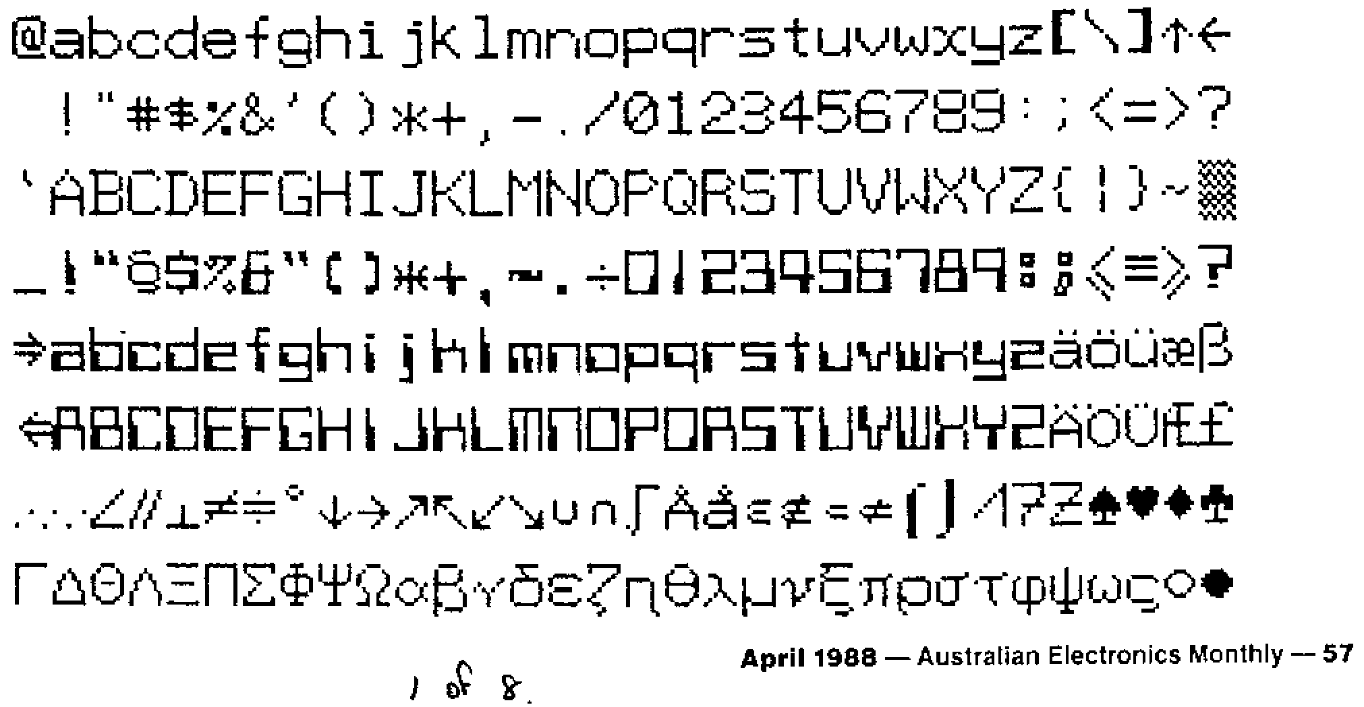
aem project 4512
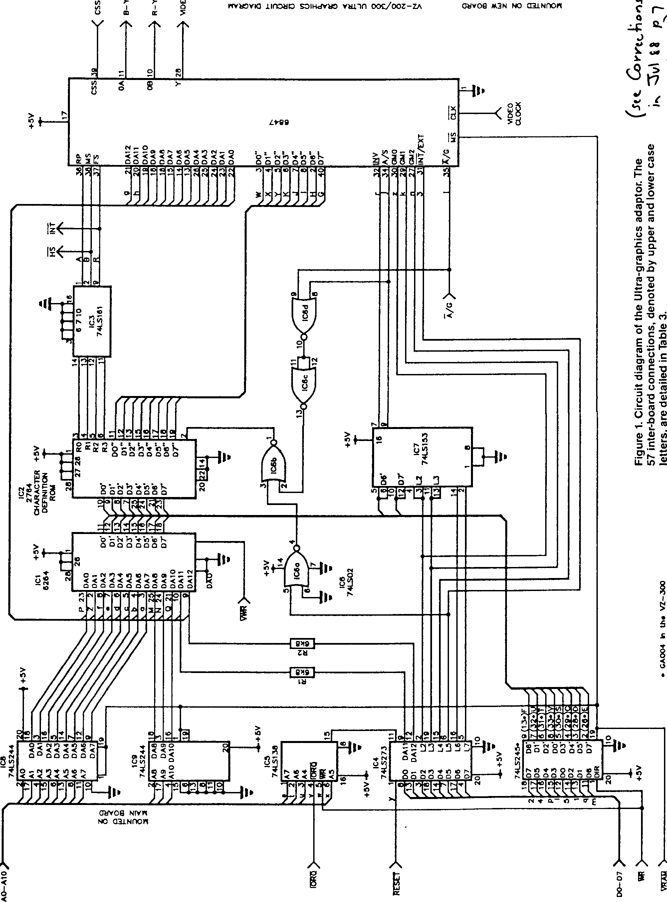

58—Australian Electronics Monthly—April 1988

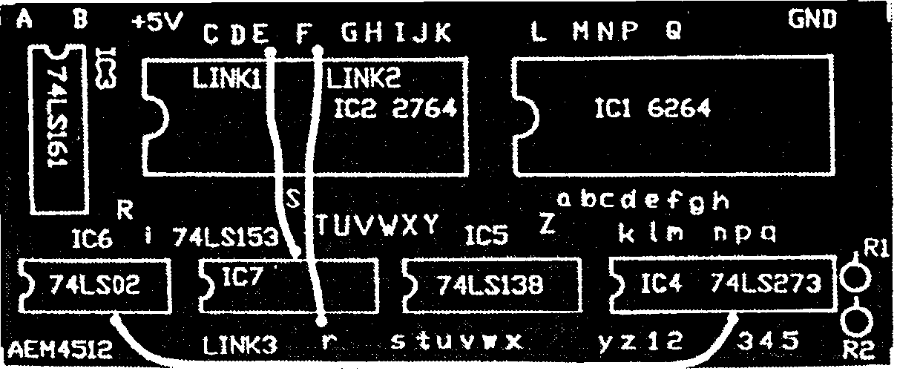
Overlay for the printed circuit board showing the placement of components and where the inter-linking wires connect. Note the links on the board.
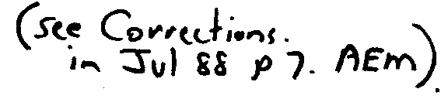
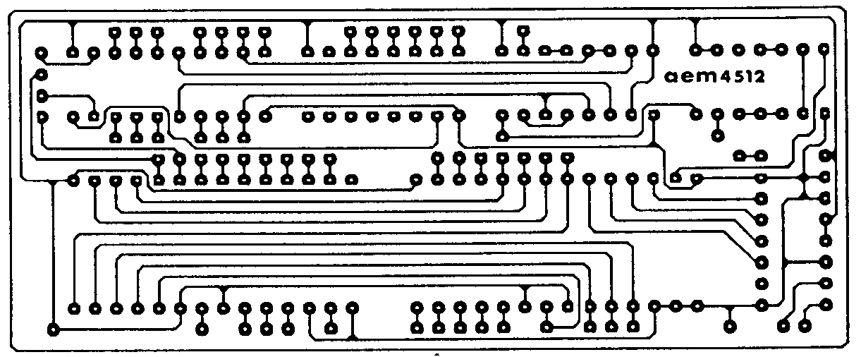
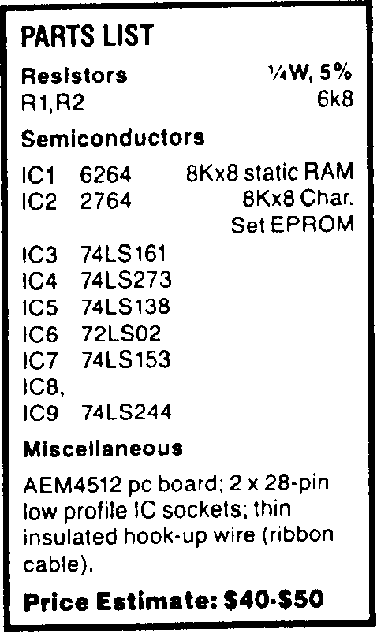

such as graphs or high resolution pictures. With an analogue to digital converter, the VZ computer could be easily used as a low cost laboratory computer, able to graph results with acceptable resolution. The highest resolution colour mode (128 x 192 pixels) is also similarly useful.
Full-size printed circuit artwork.
It is also possible to access the 3 x 2 semigraphics in text mode, which occurs when graphics characters are called while the external character generator is enabled. For more information on the graphics and text capabilities, see the two-part feature "Screen Handling on the VZ200/300", by Bob Kitch, in the September and October 1986 issues of AEM.

CIRCUIT OPERATION
IC5 (74LS138) decodes A4-A7, IORQ and WR to recognise I/O port 20-2FH(32-47). When this occurs, pin 15 goes low, causing IC4 (74LS273) to latch the contents of the data-bus (D0-d7). This latch is cleared on RESET to ensure that text is sent to the correct memory page. DA11 and DA 12 are bits 00 and 1. They provide bank switching to fit the 8K RAM into the 2K video memory allocation (7000-77FFH (28672 to 30719)). L2, L3 and L4 signals control the graphics mode pins on the 6847 video IC, L5 controls the internal/external character sets and with this the 2x2 (normal) or 3x2 semigraphics modes. L6 and L7 control whether the inverse and semigraphics modes follow bits 6 and 7 of the character code (normal) or L2 and L3 respectively.
The output of IC1 (6264) controls address lines 4 to 11 of the character EPROM. The EPROM is programmed to mirror the output of IC1 UNLESS the external character set is specifically required. In this case, pin 2 of IC2 is sent high by IC6 (74LS02), which decodes when L5 is high and the video IC is in text mode. IC7 (74LS153) multiplexes the inverse and semigraphics control lines, and is controlled by L6 and L7 to decode L2, L3, D6' and D7'.
IC3 (74LS161 ) is a synchronous binary counter. It counts through the external character set in the EPROM, so that the correct character row data is released.
* A fully programmable EPROM with the character set in Chart 1 is available from:
Matthew Sorell, 41 Mills St, Clarence Pk, 5034 S.A.
for $18 including postage. Customised character sets are negotiable. Kit suppliers may include pre-programmed EPROMs; check with your supplier first.
Construction
The first thing to do, no matter whether you've purchased a kit or assembled your own parts and made your own printed circuit board, is to check the pc board. See that all the holes are drilled and that there are' no broken tracks or tiny copper 'bridges' between the closely-spaced IC pads. Correct any problems you find.
You can commence assembly by first installing the resistors, IC sockets and the non-socketed ICs into the printed circuit board, as shown in the overlay diagram here. The three links should be made on the solder side of the board using insulated wire. Now install the 57 interconnecting wires as required. Make these about 150-200 mm long for the time being. The wire used should be as thin as possible. Separated ribbon cable is quite suitable. The wires should be connect through the component side of the pc board.
Now open the computer by removing the six screws underneath. Remove the main board by undoing the four screws holding it in. Be careful not to flex the keyboard cable too much; if it breaks, it's the devil's own job fixing it. Note which wires go to the power switch and the loudspeaker, then desolder these, leaving the wires on the main pc board.
Desolder the RF shield covering the main board. Use solder wick to do this. Remove the 6116 RAM on the main board, near the TV modulator. The best way to do this is to cut the pins on one side of the IC and wobble it on the other side until the rest of the pins break. Just make sure you've got go the right chip! Now remove the pin stubs left in the pc board. >
LEVEL
We expect that constructors of an INTERMEDIATE level, between beginners and experienced persons, should be able to successfully complete this project.
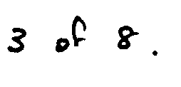

April 1988 — Australian Electronics Monthly — 59
aem project 4512
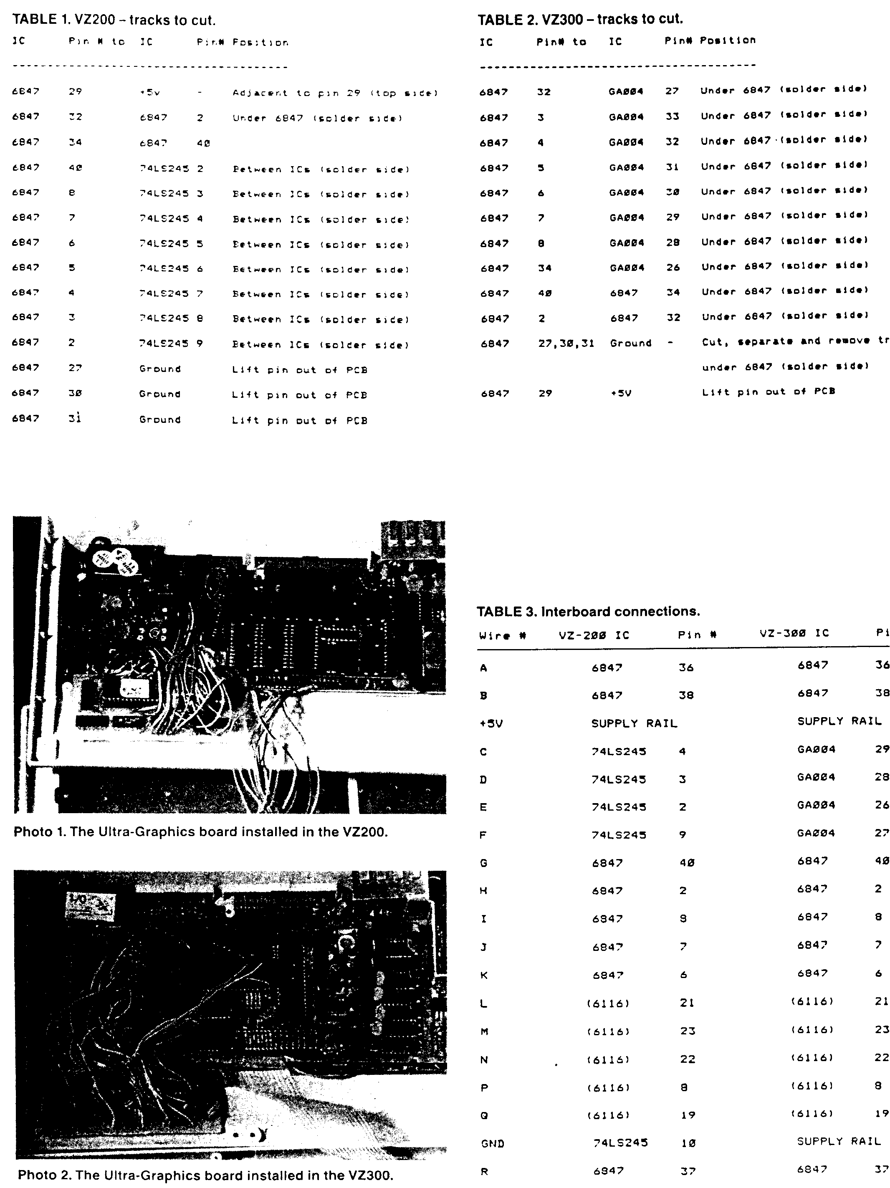

60 — Australian Electronics Monthly — April 1988

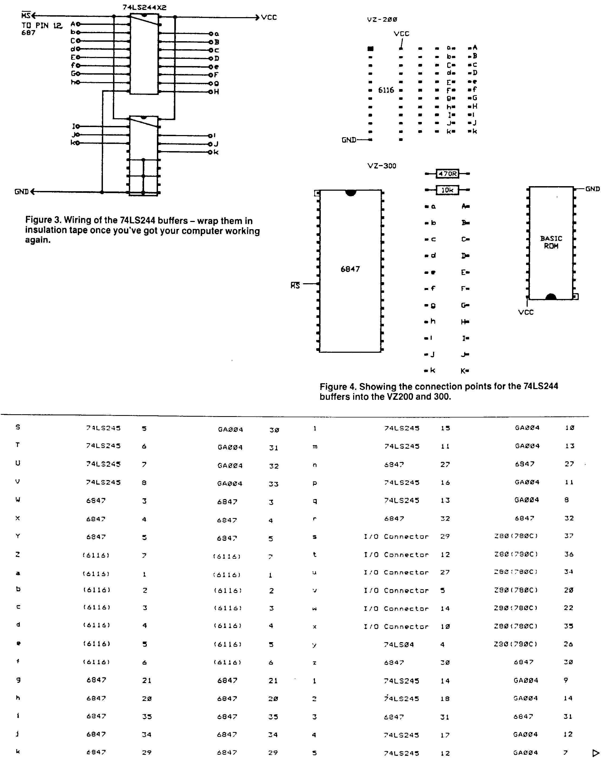


April 1988 — Australian Electronics Monthly — 61
aem project 4512

Figure 3. Clip the narrow part of each pin. and connect these ICs to the board via short (20 mm) pieces of wire, longer for the power supply and enable signal. Connect them as shown in Figure 4. Wrap these ICs in insulation tape. Switch the computer back on, and when the computer is working, check the new board by typing in:
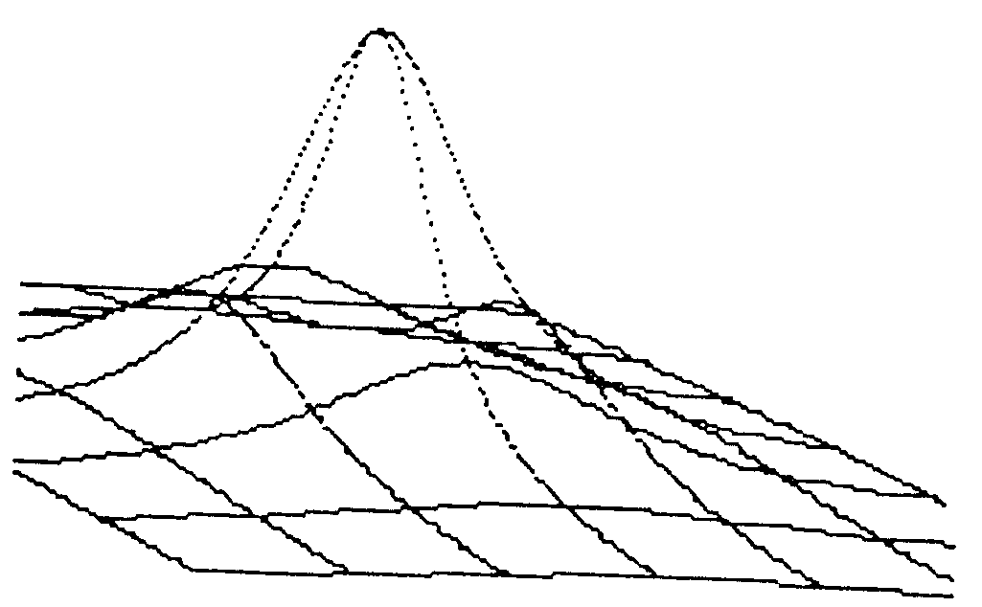
Figure 2. Three-dimensional graphics!
This method greatly reduces overheating problems. Missing tracks are an absolute no-no in computers!
In the VZ200, undo the two screws holding the PAL converter module behind the TV modulator and lift up, to reveal the 6847 video IC. There are two plastic screw mounts on the base of the VZ200. These should be broken off with pliers.
Now the fun begins! Cut the tracks listed in Table I (VZ200) or Table 2 (VZ300). Identify each track carefully! Note several IC pins are lifted. When doing this, heat them with a soldering iron and lever the pin out using a small precision screwdriver. Be careful not to break the pin at the IC or all will be lost! Clip off the narrow part of the pin.
Position the Ultra-graphics board in its approximate location relative to the main board. See Photo I (VZ200) or Photo 2 (VZ300). Connect each wire in order, as in Table 3, to the main printed circuit board on the component side. Cut the wires with a little leeway (about 10 mm longer than required). Tick each connection in Table 3 as it is made. to avoid errors.
Check and recheck all connections. Reconnect the loudspeaker and power switch, fit the main board back into the box (no screws yet) and the new board alongside, as in the photos. Plug in the RAM and EPROM, the video and power supply cables, and switch on. The display should be almost normal. Some characters may be incorrect. The computer should otherwise work correctly. If not, then check for short and open circuits, incorrectly oriented components, and incorrect inter-board wiring.
Unfortunately, the Z80 has trouble controlling the address lines through the resistor buffer with this new board, making the graphics only about 90% accurate. To correct this, power down and then remove the eleven 6k8 resistors on the main board (in the VZ300, do not remove the adjacent 10K and 470R resistors). Wire up IC8 and IC9 (74LS244) as shown in
10 CLS:POKE 30744,96:OUT 32,224
20 FOR A=0 TO 255
30 POKE 28672+A,A
40 NEXT
50 PRINT@256,""
and running this little program. The new external character set should be displayed.
Screw the board into the box, and the cover on top. Voila. Ultra-Graphics!
The RF shield can be reinstalled, but creates a few problems with mounting the new board. It is not essential for the computer's operation and can be left out if you wish.
Applications
It's no use having a set of useful new features without suitable applications with which to exploit them.
The Word Processor
The character set has been designed to be used in conjunction with the tape version of the word processor. Not having used the cartridge version, I don't know how the new character set should be enabled, or if it is compatible with (his word processor. To enable a suitable character set, type in:
POKE 30744,96:OUT 32,160
before loading the word processor. Upper and lower case will be enabled, and semigraphics characters will be used as markers. You will find that the word processor is now considerably easier to use.
Text in BASIC
When using the external character set with BASIC, the white-on-black screen should be enabled. BASIC revision 1.2 uses-only this mode, but version 2.0 boots up in black-on-white (inverse mode). Since characters 96 to 127 are non-standard, the white-on-black mode should be enabled by typing POKE 30744,96; or by keeping CTRL depressed when turning the computer on.
As mentioned earlier, characters 128-255 can be accessed by poking the correct code onto the screen, or by printing the correct graphics character in the correct colour. This is how photo six was produced. Characters 64 to 127 can be accessed as inverse characters. The character sets available are listed in Table 5.
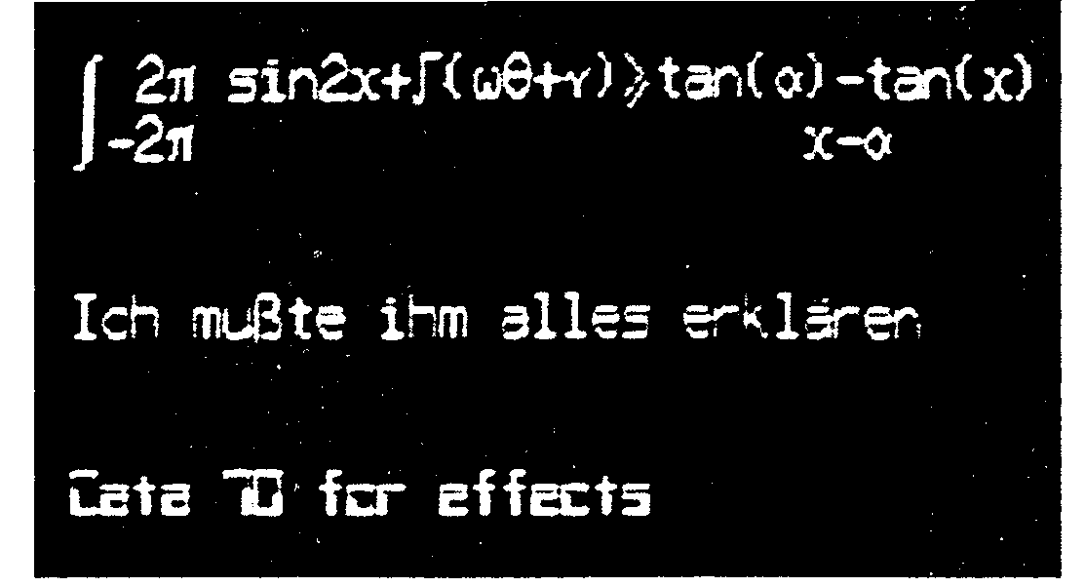
Using Graphics
The computer now boots in graphics mode 0, so before any commercial software (games) can be loaded, you should type in: OUT 32,8
to enable the normal graphics mode.
If you have a GP-80 printer, which is compatible with the graphics dump screen, then it is possible lo dump games screens by playing the game in graphics mode 6 (128 x 192) on the second RAM page (OUT 32,25). (connect a reset pushbutton to ground on pin 13 (VZ200) or pin 11 (VZ300) of the 74LS04. Reset the computer at a suitable point in the program, and print the screen by typing in:
MODE(1):OUT32.25:COPY:OUT32,0
Photo 5. A small taste of what is now possible with text: mathematics, German and Data 70 characters.
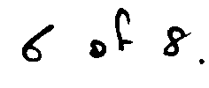

62 — Australian Electronics Monthly — April 1988
Using Extension Graphics
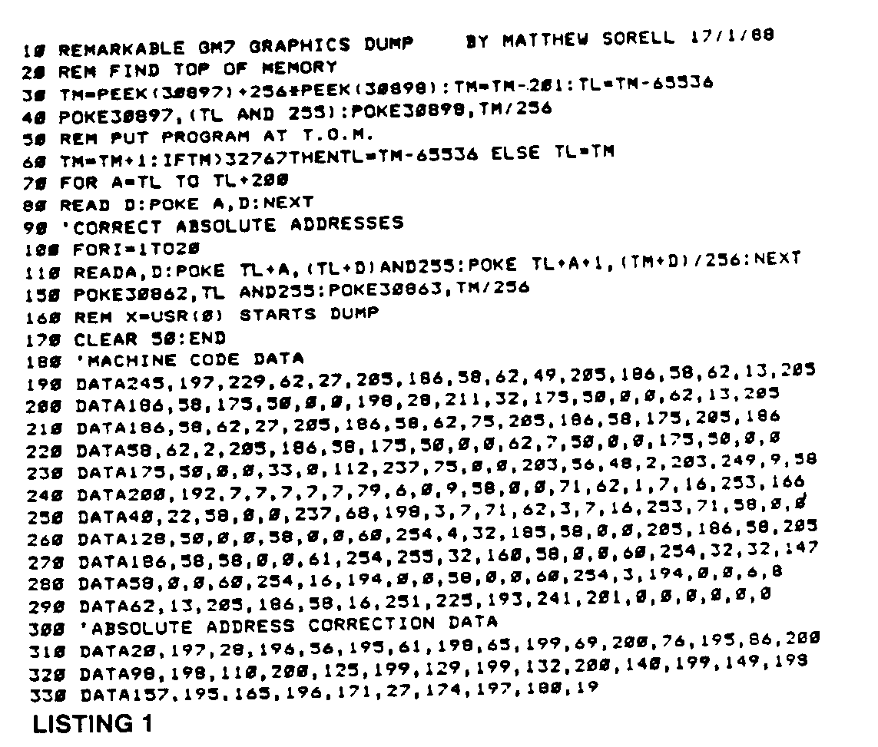
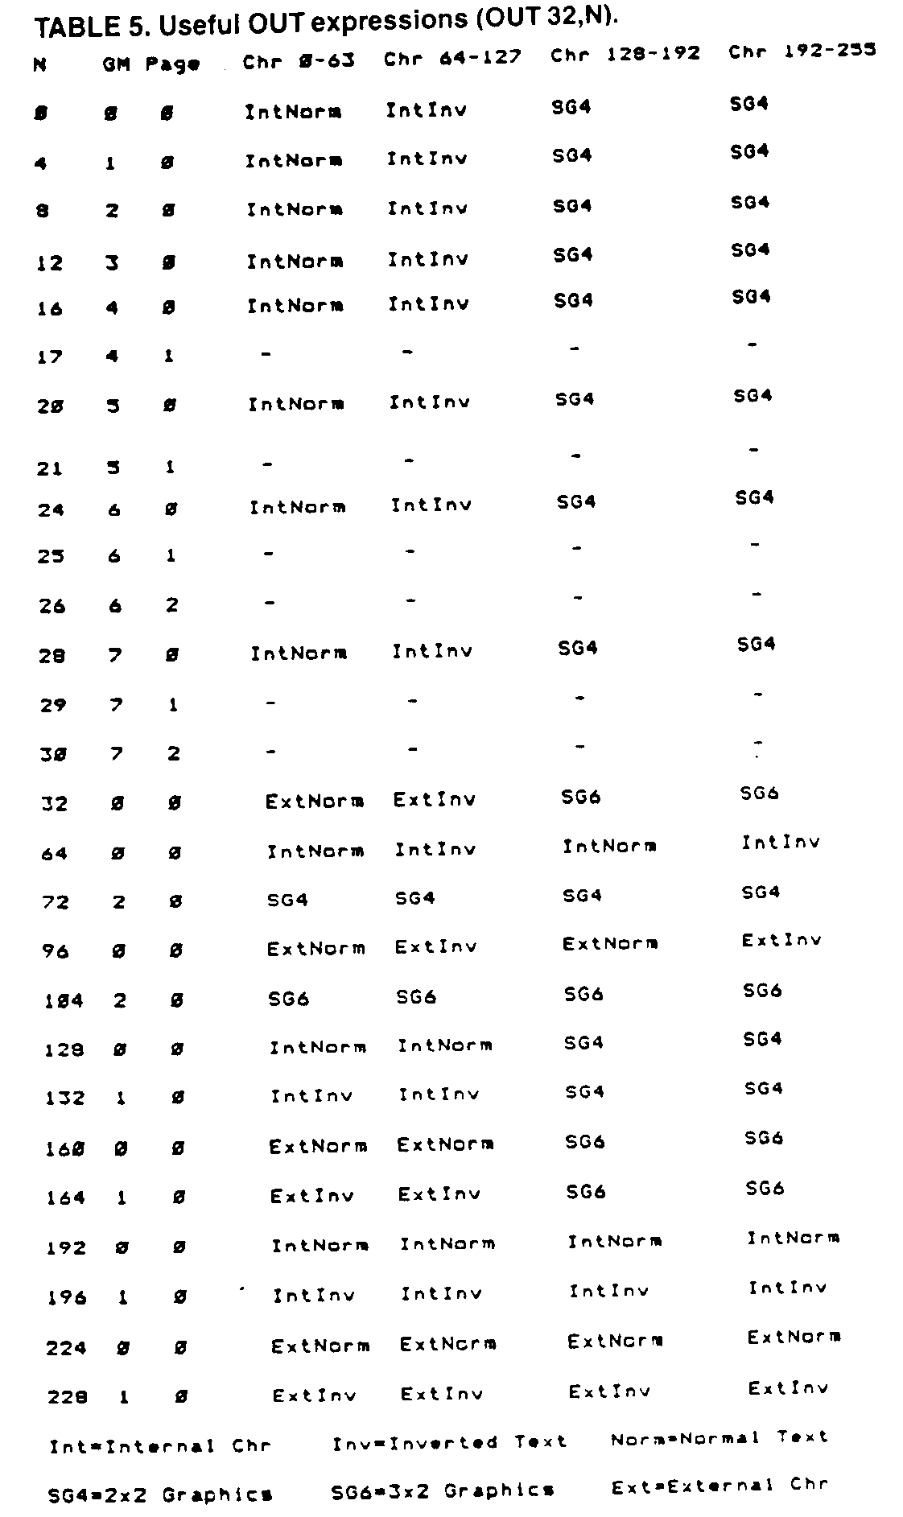
The following graphics modes are available:
GM0 | OUT32,0 | 64x64 | Colour | 1024 Bytes
GM1 | OUT 32,4 | 128x64 | Monochrome | 1024 Bytes
GM2 | OUT 32,8 | 128x64 | Colour | 2048 Bytes
GM3 | OUT 32,12 | 128x96 | Monochrome | 1536 Bytes
GM4 | OUT 32,16 | 128x96 | Colour | 3072 Bytes
GM5 | OUT 32,20 | 128x192 | Monochrome | 3072 Bytes
GM6 | OUT 32,24 | 128x192 | Colour | 6144 Bytes
GM7 | OUT 32,28 | 256x192 | Monochrome | 6144 Bytes
The COLOUR command is valid for all colour modes. To set or reset a pixel in each mode, in mode I, refer to Table 4. To clear the screen in modes 4 to 7, MODE(1) must be enabled on all RAM pages used. This means that the GM7 screen is cleared by using:
OUT 32,30:MODE(1):OUT 32,29:MODE(1):OUT 32,28:MODE(1)
The method is similar for the other modes. A three dimensional plot, based on a Microbee program, but using Graphics Mode 7 instructions is reproduced here.
Listing 1 is a graphics dump routine for Graphics mode 7, written for Shinwa-compatible dot matrix printers, such as the BMC BX-80. The author would appreciate hearing from anyone writing applications software for this graphics modification.

April 1988 — Australian Electronics Monthly — 63

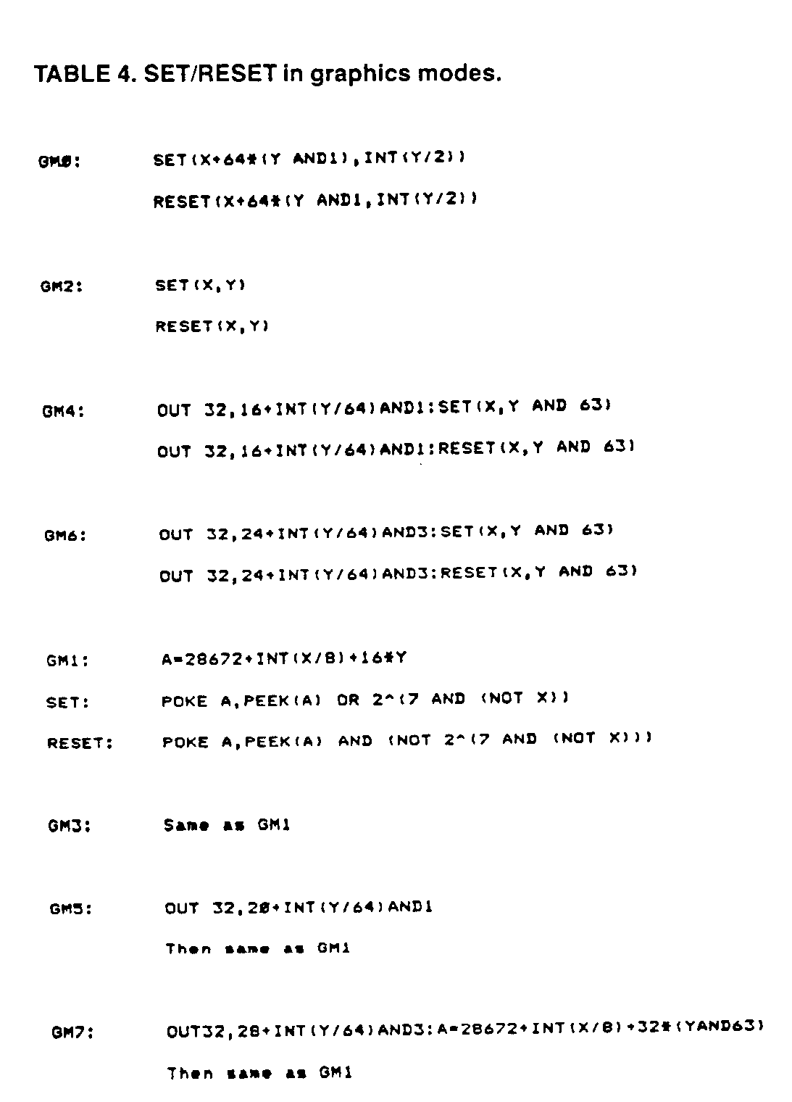

OOPS! The pc board artwork for the AEM4512 VZ Ultra-Graphics Adapter was reproduced upside-down with the board number right-reading. Strange? Here it is, the correct way.

June 1988 — Australian Electronics Monthly — 7

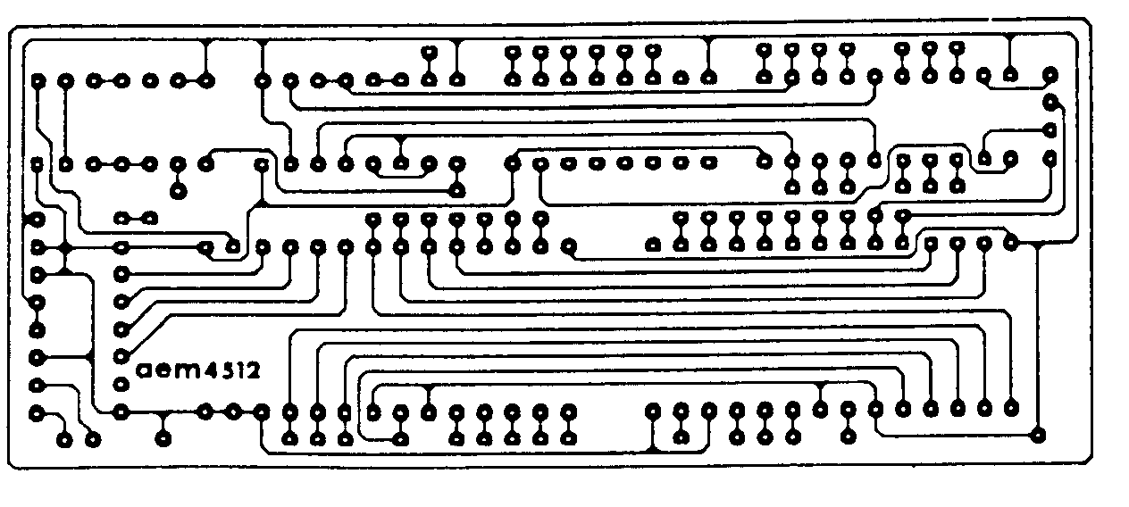
Project 4512. VZ "Ultra-Graphics Adapter", April '88. On the overlay. 'V' goes to pin 10 of IC2 (the 2764) and 'J' is missing - it goes to a pad just above pin 9 of IC7 (the LS153), presently obscured by the point of the V. On the circuit (p.58). IC3 (theLS161) has pins 3,6, 7, 10 and 16 shown earthed when they go to +5V, while pins 4,5 and 8 were omitted - they go to earth.
July 1988 — Australian Electronics Monthly — 7


